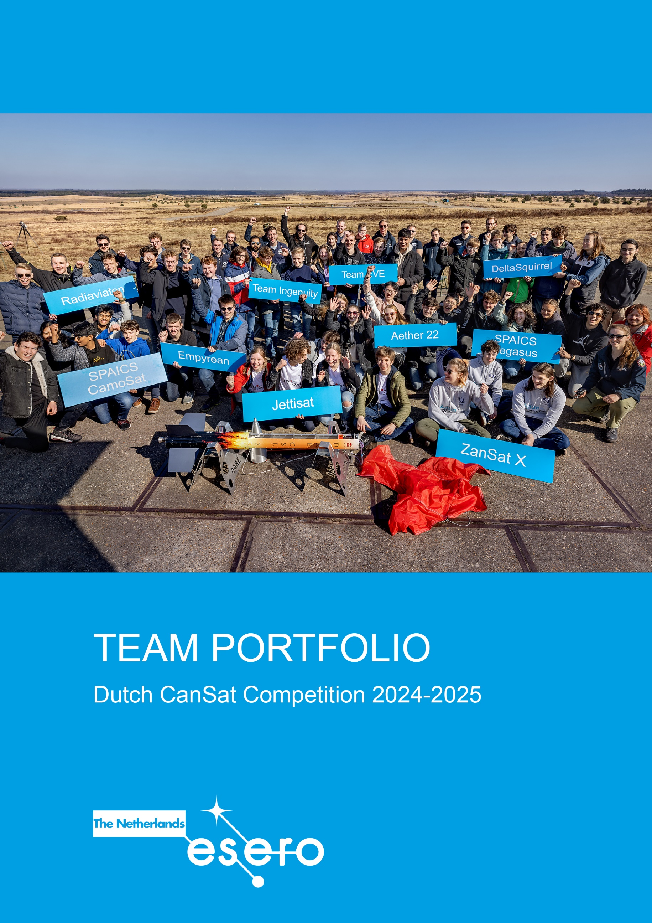

# **Template Progress Report**

The progress report provides the organisers with a status update on your CanSat project and mission in preparation. You will receive feedback on this report on the test day during a consultation with an expert

The **maximum length** of the Progress Report is 6500 words.

Email your completed Progress Report no later than **21 January 2025, 15.00 hrs** to [Info@esero.nl](mailto:Info@esero.nl) . Please use the subject line: “CanSat Progress Report [TEAM NAME]”.

***Instructions***

*This is a template for your CanSat Progress Report. Please copy and paste the template into a separate document and follow it as it is but leave out the instructions. Maximum page limit 6500 words.*

*In the Progress Report it is important that you*

* *Describe and explain any adjustments you made on the plan you described in your proposal.*
* *Describe issues, complications and problems you have encountered and how you have solved them, or plan to solve them.*
* *Show that your design is technical correct and achievable within time, budget and technical requirements.*
* *Demonstrate (explain) for each listed requirement how it is met or will be fulfilled. If relevant, add photos or drawings as a proof. Show measurements. Show calculations (in text, no scans allowed). Describe tests you have done. Be specific, a simple yes is not enough.*

**Template Progress Report**

*check* [esero.nl/CanSat](http://www.esero.nl/cansat) *for the deadline!*

# General

### Team:

### School:

### City:

Progress statement (summary)

*(A brief statement to give a quick overview of the progress so far.*

*E.g., important changes in your project, status of ordered parts, produced parts, any issues you have encountered and solved, any open issues, but also extraordinary successes)*

1. Mission Overview
   1. *Primary Mission*

*(List the objectives of the primary mission)*

* 1. *Secondary Mission*

*(Describe your secondary mission. Are there any changes in the secondary mission since you submitted the proposal? If so, explain what you have changed and why)*

* 1. *Scientific and/or technical objectives*

*(Outline your scientific and technical objectives. Explain how you aim to achieve these objectives (e.g. sensing capabilities required, special designs needed, data analysis). Has anything changed since your proposal?)*

* 1. *Data measurements and analyses*

*(Describe in a concise way which data you will measure and how. Include your plans on how you will analyse the data)*

* 1. *Design specifications*

*(Give an update on the progress on the design of your CanSat)*

1. CanSat Design and Technical Requirements
   1. *Design specifications*

*(Describe the planned design of your Cansat. Include high level descriptions, diagrams and basic sketches. What software and what hardware will be used. Include calculations)*

* 1. *Testing*

*(Provide your plan for testing. Describe the results of tests you have already done and list the tests you still plan to do)*

* 1. *Technical Requirements*

*Describe how your CanSat will meet the requirements listed below. Show proof. Include calculations and pictures were helpful. If your CanSat does not meet a requirement yet, describe your plans to solve this.*

*The requirements listed below are essential in this stage of the competition. (For a detailed overview of all requirements,* ***check the competition guidelines on***[*www.esero.nl/cansat*](http://www.esero.nl/cansat) *If your CanSat does not meet these criteria, you may not be able to launch your CanSat at the Test Day.*

Requirement 1

*(All the components of the CanSat must fit inside a standard soda can (115 mm height and 66 mm diameter), except for the parachute. An exemption can be made for radio antennas and GPS antennas, which can be mounted externally (on the top or bottom of the can, not on the sides), based on the design. The rocket payload area has a maximum of 4.5 cm of space available per CanSat, along the can’s axial dimension (i.e. height), which must accommodate all external elements including the parachute, parachute attachment hardware and any antennas. If other parts are mounted on the top or bottom of the can, please list these here and include their dimensions)*

Requirement 2

*(The antennas, transducers and other elements of the CanSat cannot extend beyond the can’s diameter until it has left the launch vehicle. If you have mechanical parts that will move after deployment, prove that they will remain in position before deployment)*

Requirement 3

*(The mass of the CanSat must be between 300 grams and 350 grams. CanSats that are lighter must take additional ballast with them to reach the 300 grams minimum mass limit required)*

Requirement 5

*(The parachute connection must be able to withstand up to 50 N of force. But we strongly recommend a strength up to 200 N. The strength of the parachute must be tested, to give confidence that the system will operate nominally)*

Requirement 6

*(The CanSat must be able to withstand vibrations resulting from an acceleration of up to 20 G. This vibrational load is applied to the CanSat during the propelled portion of the launch. Explain what tests you have performed or plan to perform to prove this. Be sure to perform this test with electronics aboard, as these form the most vulnerable part)*

Requirement 7

*(For your parachute design take into account that a minimal average descent rate of 13 m/s is required for safety and recovery reasons. Explain your parachute design, size and how this ensures you comply to this requirement. When systems other than single stage parachuting are used, exceptions are possible in consultation. Describe your system and (planned) tests extensively)*

|  |  |
| --- | --- |
| ***!*** | *Please note that explosives, detonators, pyrotechnics, and flammable or dangerous materials are strictly forbidden. All materials used must be safe for the personnel, the equipment and the* *environment.* |

1. Outreach
   1. *Outreach Plan*

*(Describe your outreach program. What target group(s) have you chosen and why. What is your message to them and how will you reach them?)*

* 1. *Progress*

*(Describe the work you have already done for your outreach program)*

# Project management

## *Team*

*(Describe the organisation of your team. Have any changes been made since you started working on your Cansat? Explain if relevant)*

## *Planning*

*(Does the project proceed according to your original planning, or did you have to adjust this? If so, describe what went different and what adjustments you have made)*

## *Finance*

*(Is the financial plan that you made still appropriate, or did you have to adjust it? If you need sponsors, describe how the search and finding of sponsors is proceeding)*