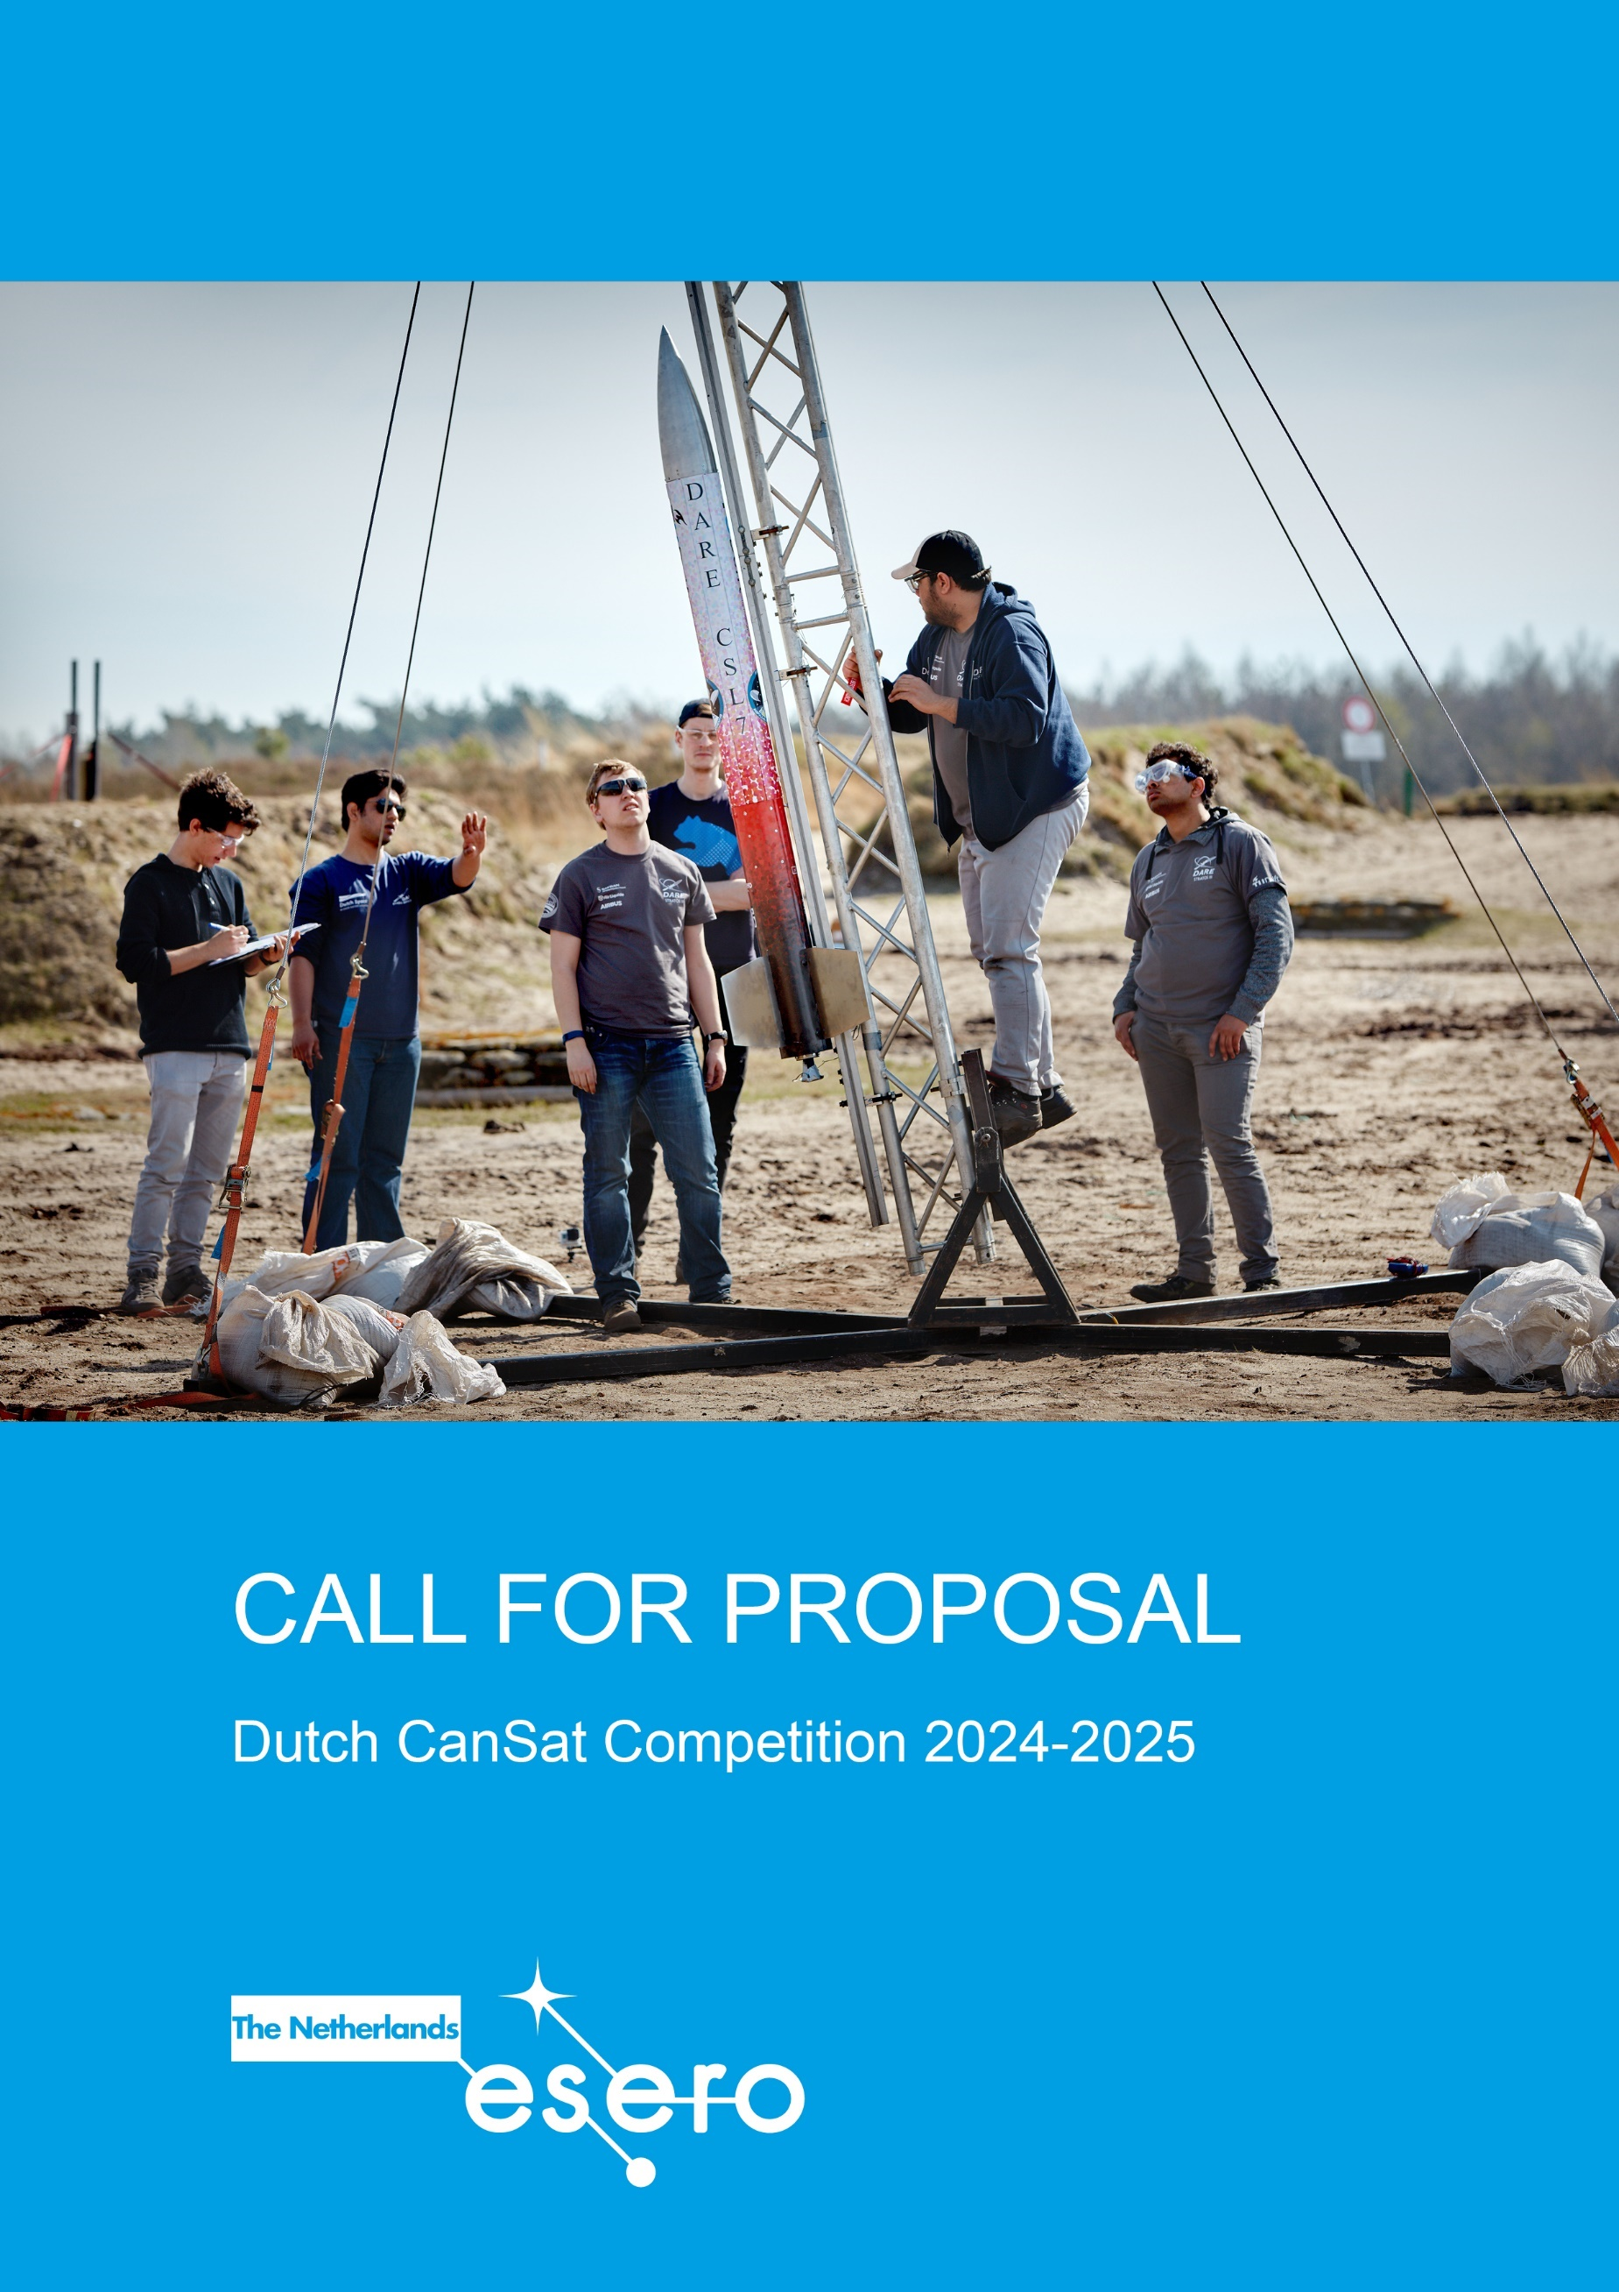

# **Call for proposal Dutch CanSat Competition**

Have you ever dreamed of becoming an astronaut, a rocket scientist or a space engineer? Now is your

chance! In the CanSat competition, you can lead your own space mission - with a satellite the size of a

soft drinks can. Together with a group of fellow students, you will compete against teams from all over

the country. Submit your proposal to be part of the Dutch CanSat Competition 2024-2025! The deadline is **3 PM, Thursday 17 October 2024**.

## Who can apply?

The competition is open to teams from secondary schools in the Netherlands. Team members must be between the age of 14 and 19 at the time of the competition and at least 50% of the students included in a team must be nationals of an ESA Member State or Associate State (a full list of Member States & Associate States can be found [here](https://www.esa.int/About_Us/Corporate_news/Member_States_Cooperating_States)). Each team should comprise between 3-6 students, assisted by a teacher or tutor. A maximum of two teams per school can participate in the competition.

In 2024-2025 we will conduct a small pilot for MBO-teams. Would you like to participate? Please contact us at [info@esero.nl](mailto:info@esero.nl)

## How to apply?

Start by reading and studying the CanSat Guidelines 2024-2025 carefully. These are published on the website of the Dutch CanSat competition [esero.nl/cansat](http://www.esero.nl/cansat).

Use the template in this document to write your proposal (max 4 pages). Please copy and paste the template into a separate document and follow it as it is but leave out the instructions.

The teacher or tutor has to send the following documents to [info@esero.nl](mailto:info@esero.nl) before the deadline. Use the subject line: “2024-2025 CanSat Competition Proposal [TEAM NAME]”. Please send the documents themselves, not a link to a shared document service.

* The Proposal
* A Photography & Filming consent form for each team member, including the team leader
* A completed Personal Detail Form

All documents can be downloaded from [esero.nl/cansat](http://www.esero.nl/cansat)

A maximum of 40 teams will be admitted to the competition. Teams will be selected based on the quality of the proposal and the technical feasibility of their secondary mission. After your proposal has been submitted and evaluated, you will be notified if your team is admitted.

**Template Proposal**

*Deadline* **3 PM, Thursday 17 October 2024**

***Instructions***

*This is the template for your CanSat proposal.*

* *Please copy and paste the template into a separate document and follow it as it is, but leave out the instructions.*
* *Maximum page limit 4 pages.*
* *Before submitting your proposal, please ensure that you have read carefully the Competition Guidelines available at* [*www.esero.nl/cansat*](http://www.esero.nl/cansat)
* *Please do not forget to include the Personal Detail Form and a Photography & Filming consent form for each team member.*

# General

### Team:

### School:

### City:

# Mission overview

## *Primary mission[1]*

*(List the objectives of the primary mission– such as given in the CanSat requirements)*

## *Secondary mission*

*(Describe the secondary mission you have chosen for your CanSat. Outline the scientific and/or technical objectives (What are you going to measure/investigate/test)*

*Explain why you have chosen this mission and why you think it is important.*

## *Scientific and/or technical objectives*

*Describe how you aim to achieve the objectives of your primary and secondary missions. (e.g. sensing capabilities required, special designs needed, data analysis). Highlight any innovative aspects.*

# Outreach program

*(Describe your first ideas for an outreach program for before, during and after the CanSat competition. Describe your target group(s), your message/goal, and the means you plan to use to reach your target group. E.g., newspaper articles, local radio, webpage, presentation at school, social media, etc.)*

# Project management

## *Team*

*(Describe how you will distribute the tasks between team members. Consider all aspects of your project (coordination, hardware structure, software, data analysis, outreach, etc. Keep in mind that your team is your most vital resource.  You must be aware of your competencies and be able to identify where you may need to expand the team or look for external support)*

## *Tools and support*

*What external support and tools do you need to make your project a success? (e.g. workshop, laboratory, materials, machinery, expertise). If you have already identified materials, tools or support you need, describe how you plan to obtain these.*

## *Planning*

*(How much time will you have available to work on your CanSat and how will you plan it?)*

## *Finance*

*(Describe how you plan to finance your expenses (max €500 excluding ground station and non-flying items). Do your school or other sponsors support you?)*

1. (Note: Primary mission is the same for all teams. However, the teams should investigate and describe how they aim to achieve the primary mission objectives and what can be deducted from data acquired.)